

Dr. Dylan, Wilson inc.
2018-08-05
Dr. Wilson
10995 Le Forge, Port Theresaburgh, PR 13543
Phone: 507200972
Fax: 9426937556

Re: Shelley, Jackson
PHN: 837167636
Birthdate: 17-May-1938
Address: 432 Diane Lodge Suite 699, Port Christopher, FL 44092
Patient number: 2285999109

To Whom It May Concern:

This is a medical letter to state the above patient is pregnant with expected delivery date of 28-Oct-2025. Hoping this information is satisfactory for your requirements.

Thank you.

Sincerely,
Dr. Dylan, Wilson
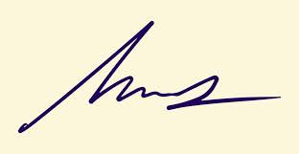
FRCS© NCMP
Clinical Assistant Professor, UBC
Department of Obstetrics and Gynecology SMH

